**Galaxy Buds FE**

SM-R400NZAAMEA

[**Product Ratings :4.7(Number of Ratings :3)**](javascript:void(0))

**Choose your color**

**Color :**Graphite

**Galaxy Buds FE**

Graphite

**₨. 33,399.00**

[**Add to cartWhere to buy**](javascript:;)

**key features**

Ergonomic Comfort

Turn the world off with powerful ANC

Enriched Bass Sound

30-Hour Battery Life

Galaxy Buds FE shown with the two earbuds hovering over the slightly opened charging case.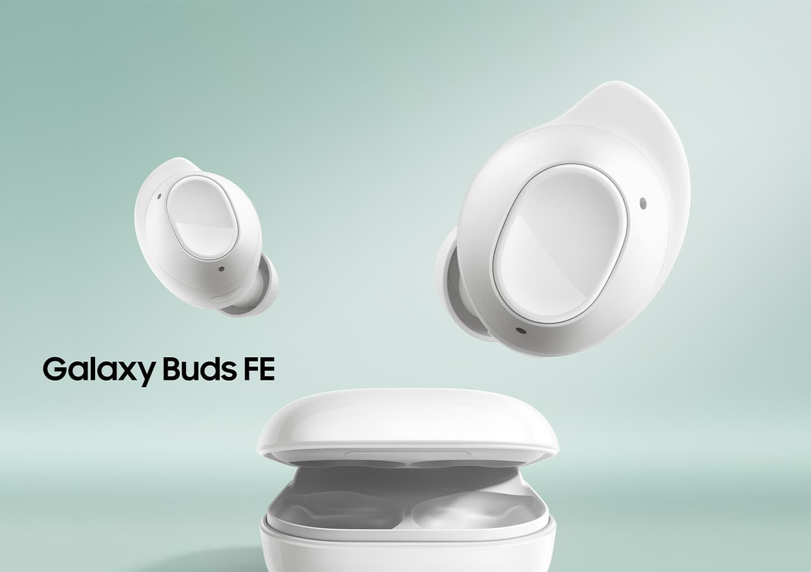

**Galaxy AI is here**

Elevate your Galaxy AI experience with Galaxy Buds FE. Now you have a translator right in your ear. Turn on the translation features on your Samsung Galaxy smartphone with Galaxy Buds FE on. Make friends with no language barrier when talking face-to-face or over the phone.

**[Face-to-face](javascript:void(0);)**

**[Over the phone](javascript:void(0);)**

Keep your Galaxy Buds FE on, even when making a friend during a trip. Just turn on the Interpreter app and it will translate right into your ears. Then Galaxy Buds FE will catch your words and Samsung Galaxy smartphone's speaker will translate to your new friend.

GUIs of Interpreter app can be seen, with translated English and Spanish onscreen. Between the GUIs are text and icons that indicate two-way translation through speakerphone and Galaxy Buds.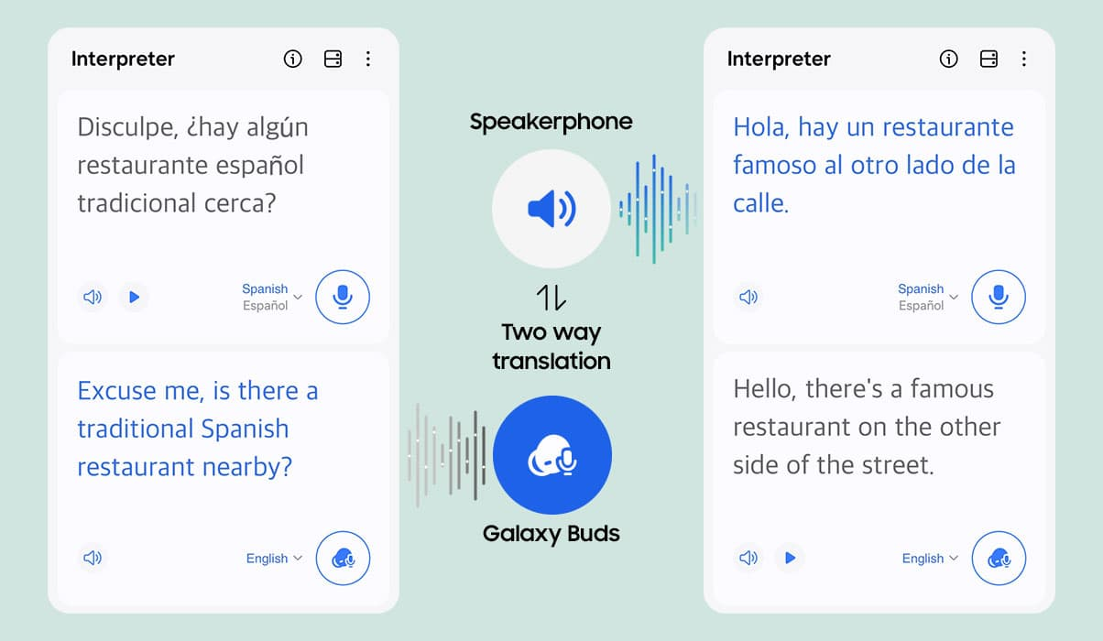

*Interpreter feature requires Samsung Account login. Certain languages may require language pack download. Service availability may vary by language. Accuracy of results is not guaranteed. *Live Translate feature requires a network connection and Samsung Account login. Live Translate feature is only available on the pre-installed Samsung Phone app. Certain languages may require language pack download. Service availability may vary by language, country, region or carrier. Accuracy of results is not guaranteed. *Galaxy AI features are supported on Galaxy S24 Ultra, S24 Plus and S24 as of Feb. 2024. *Samsung Galaxy devices may require the latest software update to properly support Galaxy AI features. *Images simulated for illustrative purposes. Actual UX/UI may be different.

**Your everyday audio companion**

Galaxy Buds FE, with their compact and ergonomic design, are here to deliver an outstanding listening experience. Block out unwanted noise with Active Noise Canceling, personalize the fit with various tips and seamlessly sync with your Samsung Galaxy devices. Experience the everyday audio companion that truly caters to you.

A close-up of two Galaxy Buds FE earbuds hovering.Three ear tips in different sizes hovering in formation.A close-up of two Galaxy Buds FE earbuds with sound waves coming from their inner and outer microphones.A Galaxy S23 FE device, a Galaxy Tab S9 FE device and two Galaxy Buds FE earbuds hovering midair.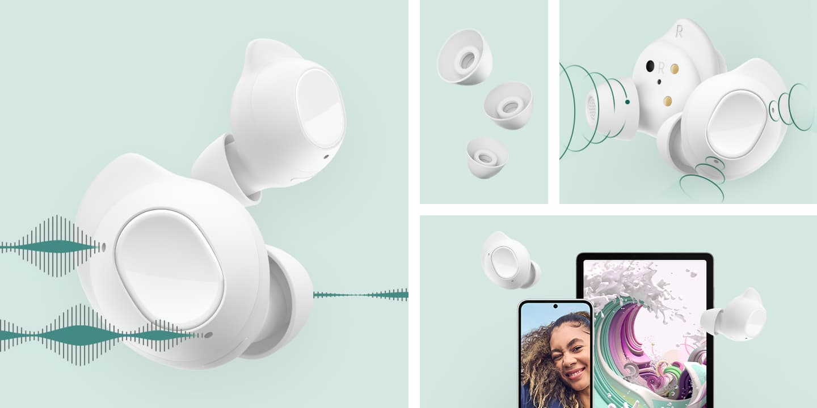

*Galaxy S23 FE and Galaxy Tab S9 FE sold separately. S Pen included with Galaxy Tab S9 FE.  
**Image simulated for illustrative purposes. Actual UI may be different.

**Timeless hues to match any tune**

Graphite and White are two timeless colors that keep you in style. They blend well with your everyday outfits, making them a versatile choice for any occasion.

An open Graphite Galaxy Buds FE case with two Graphite buds inside.An open White Galaxy Buds FE case with two White buds inside.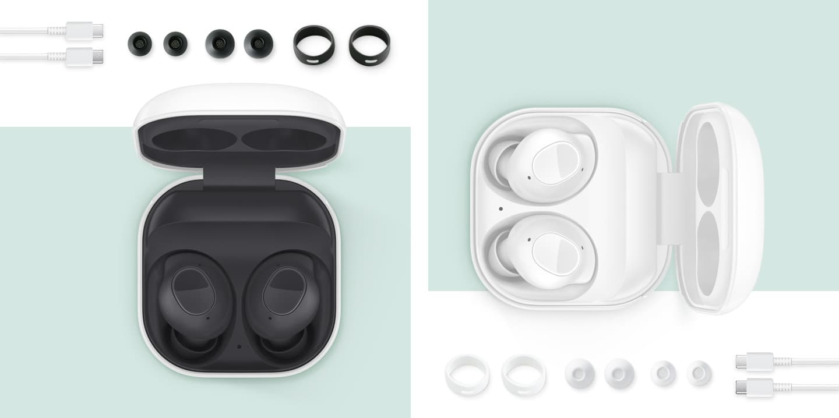

**A pair of comfort for your ears**

Galaxy Buds FE's small, ergonomic design gives added comfort as they snugly nestle in your ears and stay securely in place. Customize your earbud fit with different size choices for both wing tips and ear tips.

A close-up of the ear tip of Galaxy Buds FE.
A flat lay of wing tips and ear tips in different sizes.
An open Galaxy Buds FE case with two buds floating outside of the case.A close-up of the ear tip of Galaxy Buds FE.
A flat lay of wing tips and ear tips in different sizes.
An open Galaxy Buds FE case with two buds floating outside of the case.

**Easy touch and secure grip**

The clear distinction between the touch area and the grip area makes it easy for you to control your music and calls while keeping them securely in place.

Two earbuds of Galaxy Buds FE are shown, with one placed in front of the other. The touch area of the buds is highlighted. The two earbuds switch places. The grip area on the outer surface is highlighted.

Play video

Next

Timeless hues to match any tuneA pair of comfort for your earsEasy touch and secure grip

* *Available colors may vary by country or carrier.  
  **In-box items include the Galaxy Buds FE, a charging case, two sets of wing tips(S/M, M/L(default)), three sets of ear tips(S, M(default), L), a USB cable and a quick start guide.  
  ***Find your fit with the “Earbud fit test” menu in the Galaxy Wearable app.

**Turn the world off with powerful ANC**

Noise off, your world is on. Active Noise Canceling instantly puts you alone with your music in a quiet space. Keep the distractions out and immerse yourself in the pure sound.

A woman wearing a Galaxy Buds FE in her left ear. Her face is enclosed within a circle of wavelike lines, symbolizing the active noise canceling feature of the earbuds.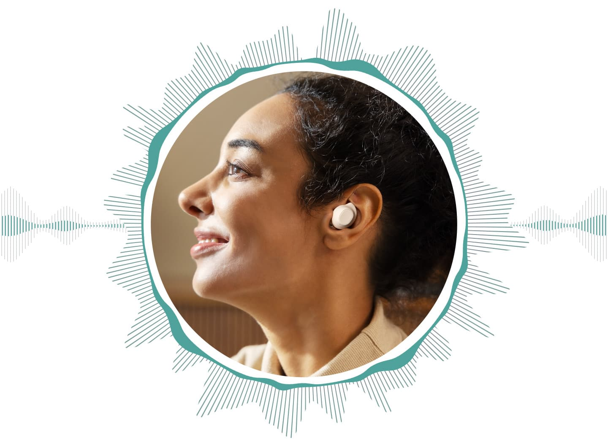

*ANC(Active Noise Canceling) is on by default, and the touch and hold gesture for ANC can be configured in the Galaxy Wearable app.

**Silence at your fingertip**

Turn the Active Noise Canceling on or off by simply touching and holding the touch area. If you want to talk to your buddy beside you, you can also switch to Ambient Sound mode to hear them without having to take off your earbuds.

*To change the 3 levels of ambient sound volume, on Galaxy Wearable app, go to Earbuds Settings > Accessibility > Customize ambient sound.  
**The touch and hold gesture for ANC can be configured in the Galaxy Wearable app.  
***Video simulated for illustrative purposes only and may not be an exact representation of the product. Actual measurements may vary.

A close-up of a Galaxy Buds FE earbuds with the texts OFF, ANC, AMBIENT. Green wavelike lines depicting audio output and a solid wavy line depicting external noise flow showing how the levels change when each mode is on.

**Enriched Bass Sound**

Indulge in rich sound of Galaxy Buds FE with deep, powerful bass from the new 1-way speaker, no matter what you're listening to.

*Image simulated for illustrative purposes.

The inside mechanics of Galaxy Buds FE to highlight the new 1-way speaker. Lines denote where 2 outer microphones and 1 inner microphone are located.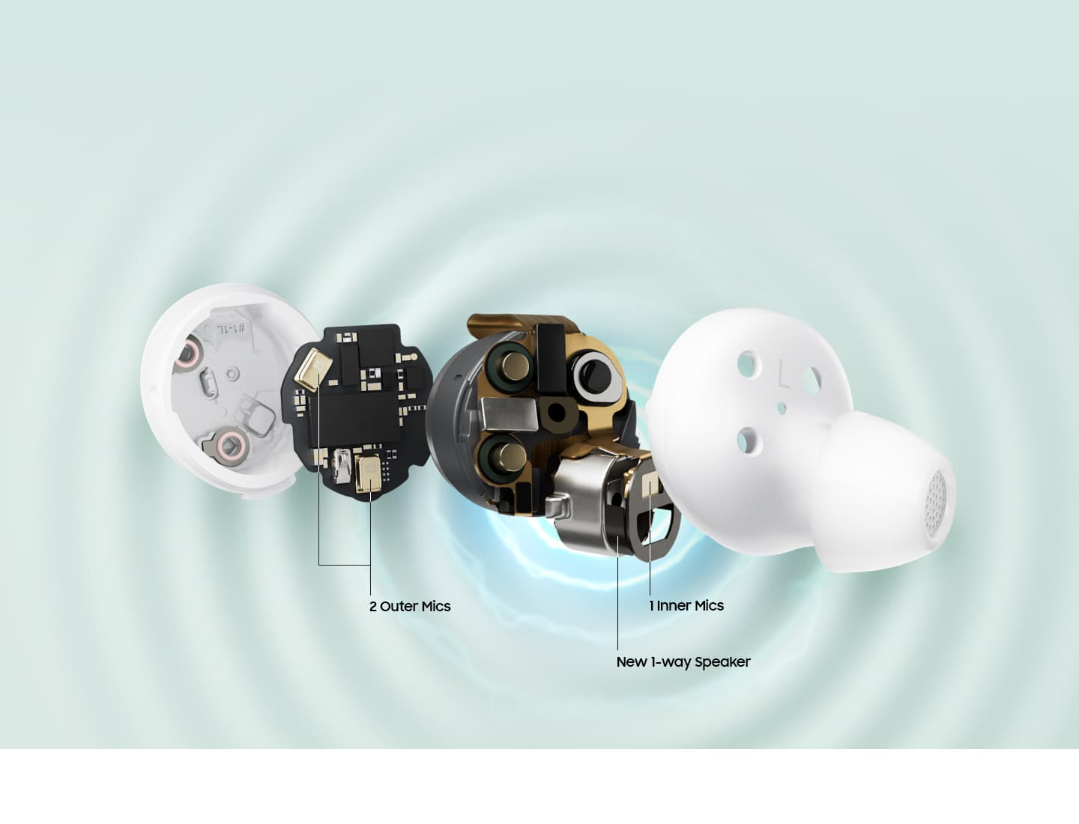

**On and on with long-lasting battery**

Compact in size, yet powerful. The battery lasts for up to 30 hours on a single charge, keeping up with your long playlist of songs, podcasts or social media videos throughout your day.

*With ANC off, earbuds and case provide up to 30 hours of play time on a full charge. With ANC on, they provide up to 21 hours of play time on a full charge. Based on internal testing. Play time tested by pairing a pre-production Galaxy Buds FE to a recently released Galaxy smartphone with default settings. Actual battery life may vary and depend on usage conditions, settings, number of times charged, Bluetooth signal strength, and other factors. 'Play time' refers to when the Galaxy Buds FE are connected to the phone, streaming music.  
**Play time may vary based on settings.

A closed case of Galaxy Buds FE with a battery depiction featuring the text Playback time 30 hours.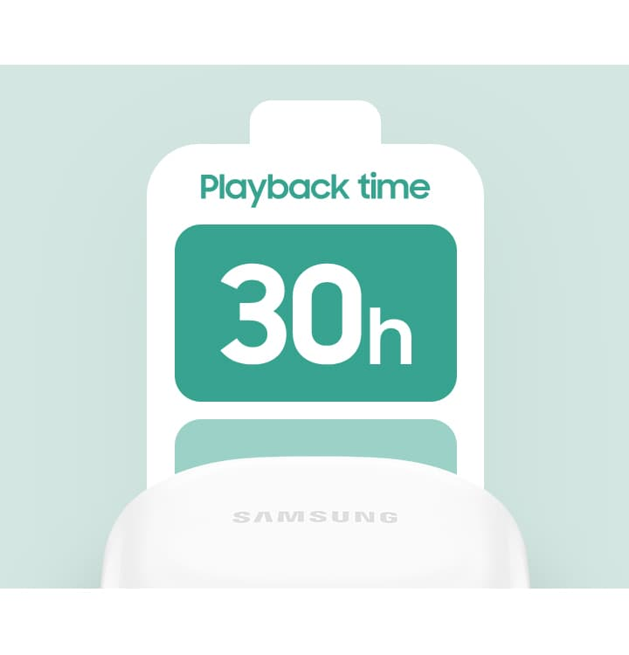

**Clear and crisp calls**

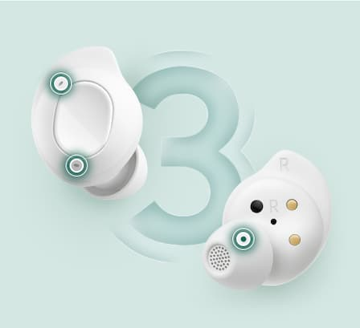

**Your voice delivered with precision**

Enjoy clear calls with three microphones on Galaxy Buds FE. Main Mic, Sub Mic and Inner Mic all work in harmony to accurately capture your voice, so your words reach the other end loud and clear.

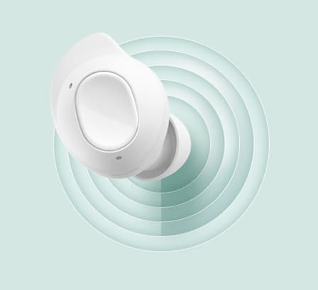

**Your earbuds, personalized for you**

Galaxy Buds FE use Personalized Beamforming to automatically adjust to your wearing pattern for the optimal pickup of your voice. Put them on and they'll locate your voice when you start talking.



**Be heard above the noise**

Whether you're in a bustling city or on a windy hilltop, your voice cuts through the noise on phone calls thanks to Galaxy Buds FE's DNN solution that adeptly filters out background noise from your voice.

**Switch to devices without pause**

Your sound follows you seamlessly as you pair with other Samsung Galaxy devices using Auto Switch, or connect with a touch or Bixby. Your sound even stays with you as you switch the playback device from your smartphone to your TV via Smart View, so you can continue watching your show on the bigger screen without missing a beat.